Chua Kah Suan
DSA4262 Sense-making Case Analysis: Health and Medicine
Assignment 1: Data Visualisation

Introduction
Postpartum depression (PPD) is a mental health condition suffered by mothers following childbirth which causes intense feelings of sadness, anxiety or despair. In severe cases, PPD can manifest in harming themselves or their newborn. Thus, PPD presents a critical public health issue that requires timely detection and intervention.
This report analyses two datasets related to postpartum mental health to explore the prevalence of PPD symptoms and the association between socioeconomic factors and its severity. It further contextualises these findings by examining childbirth patterns in Singapore to identify opportunities for maternal mental wellbeing intervention.

About the Datasets
- Data source 1: https://www.kaggle.com/code/mpwolke/postpartum-depression
The first dataset was obtained from a hospital in Bangladesh. A Google form was used to ask new mothers questions regarding PPD symptoms, such as feeling sad, anxious or guilty, changes in appetite and difficulty bonding with their baby. The data was collected over a 2-day period (14 - 15 June 2022) and includes 1503 respondents.
- Data source 2: https://www.kaggle.com/datasets/yeganehbavafa/mental-health-in-the-pregnancy-during-the-covid-19
The second dataset was collected via surveys across Canada to understand the impact of COVID-19 and related stresses on pregnant individuals and their infants. Key information used for this analysis include household income, maternal education and the Edinburgh Postnatal Depression Scale (EPDS).
The EPDS is a set of 10 screening questions that mothers who have delivered in the past 1 year can use to assess if she might be suffering from PPD. The following severity ranges were established for the EPDS:

- Data source 3: https://data.gov.sg/datasets/d_b8b0ed0ab6df784fbe33f0dba4aacb4e/view
The third dataset is sourced from the Singapore Department of Statistics and provides the annual data on live births by place of occurrence from 1978 to 2024. This dataset offers insight into childbirth trends across public and private healthcare institutions in Singapore.

Plot 1: More New Mothers Experience PPD Symptoms than Documented
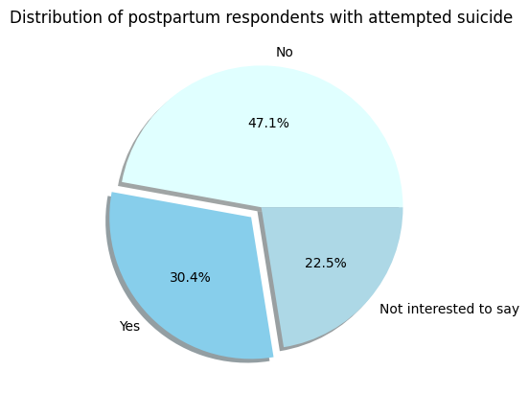
According to the Office of Women’s Health in the U.S. Department of Health and Human Services, 1 in 8 new mothers report experiencing symptoms of PPD in the year after childbirth. However, the first plot indicates that the number of mothers exhibiting extreme PPD-related symptoms in the Bangladesh dataset is substantially higher than the documented research. Notably, over 30% of respondents admitted to a suicide attempt, indicating a potentially severe mental health crisis among this sample. This reveals a gap in documented estimates and lived experiences, and raises concerns about the access to mental health support in maternal healthcare settings.
However, this finding must be interpreted with caution. The data was collected from a single hospital and over a short time frame of 2 days. Without information about the hospital’s geographic location or patient demographics, it would be inappropriate to generalise these findings to Singapore without further supporting evidence.

Plot 2: Relationship between Severity of PPD and Household Income
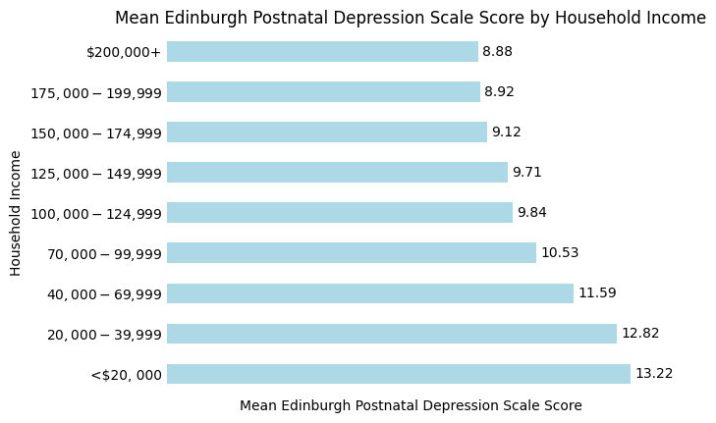
The second plot explores the relationship between household income and severity of PPD developed by new mothers, as measured by EPDS scores. The visualisation suggests that mothers from lower-income households tend to exhibit higher average EPDS scores, indicating greater severity of depressive symptoms.
However, a key limitation of this analysis is the use of mean EPDS scores, which obscures important variations within each income category. EPDS is also not a diagnostic tool, but a screening tool that aims to identify women who may benefit from follow-up care.
Furthermore, elevated EPDS scores are also observed among mothers from higher-income households, underscoring that PPD is not exclusively linked to financial circumstances. Nonetheless, the data suggests that it could be worthwhile to extend greater support to new mothers with less financial stability.

Plot 3: Increasing Proportion of Live Births in Public Sector Hospitals in Singapore
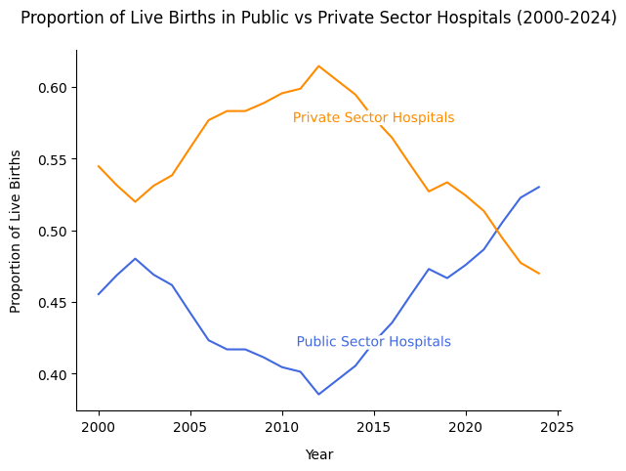
The third plot illustrates a growing proportion of live births occurring in public sector hospitals relative to private sector hospitals in Singapore. This trend reveals changing interactions between pregnant women and the healthcare system, potentially driven by cost considerations, perceived quality of care or broader structural factors.
The increasing uptake of public hospitals presents an opportunity for early identification and intervention for PPD. As public hospitals serve a growing share of new mothers, they can function as critical contact points for systematic mental health screening, education and referral to support services.
However, the plot is aggregated at the national level and does not shed light on individual-level factors such as socioeconomic status, risk profiles or reasons for hospital choice, which limits the depth of recommendations that can be drawn.

Conclusion
The first plot highlights a potentially severe and under-recognised burden of PPD, while the second plot reveals socioeconomic disparities in symptom severity. The third plot situates these insights within the Singapore healthcare system, identifying public hospitals as strategic sites for intervention.
Collectively, these findings suggest that integrating routine mental health screening and targeted support for vulnerable mothers within public maternity services could be an effective approach to addressing PPD. Further data would be needed to strengthen these conclusions and inform more precise policy interventions.
Appendix
The code for developing the plots can be found in ‘Assignment 1 - Data Visualisation’ folder on https://github.com/kahsuann/DSA4262.

References
American College of Obstetricians and Gynecologists. (2024). Postpartum depression. Retrieved February 1, 2026 from https://www.acog.org/womens-health/faqs/postpartum-depression
HealthHub Singapore. (n.d.). Edinburgh Postnatal Depression Scale. Retrieved February 1, 2026 from https://www.healthhub.sg/programmes/parent-hub/depression-scale
Journal of Reproductive and Infant Psychology. (2015). The identification of severity ranges for the Edinburgh Postnatal Depression Scale. Retrieved February 1, 2026 from https://womensmentalhealth.org/posts/using-epds-measure-postpartum-depression-severity/)
Singapore Department of Statistics. (2024). Live-Births By Place Of Occurrence, Annual (2025) [Dataset]. data.gov.sg. Retrieved February 1, 2026 from https://data.gov.sg/datasets/d_b8b0ed0ab6df784fbe33f0dba4aacb4e/view
Office on Women’s Health, U.S. Department of Health and Human Services. (2023). Postpartum depression. Retrieved February 1, 2026 from https://womenshealth.gov/mental-health/mental-health-conditions/postpartum-depression

